**Analysis Of Hotel Room Pricing in Indian Market**

**Akshay Khatter**

**Akshaykhatter97@gmail.com**

**MAIT Delhi**

**1. Introduction**

As per world travel and tourism Council (WTTC), India is one of the favorite tourist destinations from the year 2009 and will continue to be one of the favorite till 2018. Further, the Travel and Tourism Competitiveness Report by World Economic Forum, has ranked India at the sixth place in tourism and hospitality.

The purpose of this project is to analyse the pricing strategy of hotels in the Indian hotel industry. Analysis is about the hotel room pricing in Indian market and how the factors affect the price of room rent in a hotel.

Tourism in India is the third largest foreign exchange earner of the country. The booming tourism industry has had a cascading effect on the hospitality sector with an increase in the occupancy ratios and average room rates.

The data used was collected from www.hotels.in in October 2016. Data collected investigates pricing of hotel rooms in 42 cities. It includes various attributes such as FreeWifi, FreeBreakfast, HasSwimmingPool, HotelCapacity, IsTouristDestination etc which we will be found out as to how do they affect the hotel room rent. We evaluate what factors affect the price of room the most and which factors affects the price least.

**2. Overview of the Study**

The given dataset gives us an idea of the pricing of different hotels room rent within the city and on a given date. The dataset is collected from www.hotels.in. We try to use the boxplots, histograms and different graphs to take insights about the data. We also evaluate the prices of hotels are higher in metro cities as compared to the no metro city. We estimate a regression of hotel room prices in a mixed model framework. Our analysis reveals that attributes such as swimming pool, hotel capacity, metro city or non metro city, free breakfast, star rating etc does affect the price of room. Whereas attributes such as Weekend, Date and New year eve does not affect the analysis.

**3. An Empirical field Study of Hotel Pricing Strategy in India**

**3.1 Overview of all HYPOTHESIS**

We study how the price of a room at a hotel is affected by external and internal factors. We assume out of 18 factors the 3 most influencing factors are Star Rating, availability of swimming pool and Hotel capacity. We are taking these three factors on the basis of their strong correlation with room rent.

We will frame our hypothesis based on these three factors as well as with other binary functions which may affect the room rent of a hotel.

**H1:** *The average room rent in hotel having swimming pools is more than that which don’t have swimming pools.*

**H1:** *The average Room Rent in hotels with high star rating is high as compared to one which has less star rating.*

**H6**: Average RoomRent in hotels in Tourist Destination is more than than others.

**3.2 Data**

Data collected for this analysis was from the www.hotels.in. It provided data of the 44 hotels located in cities of Mumbai, Delhi, Bangalore, Chennai, Hyderabad, Ahmedabad, Kolkata, Surat,Pune, Jaipur, Thrissur, Lucknow, Kanpur, Amritsar, Indore, Kanyakumari, Agra,Madurai, Goa, Rajkot, Varanasi, Srinagar, Jodhpur, Chandigarh, Thiruvathipuram,Guwahati, Mysore, Bhubaneswar, Kochi, Mangalore, Udaipur, Pondicherry,Haridwar, Puri, Shimla, Panchkula, Darjeeling, Rishikesh, Gangtok, Ooty,Jaisalmer, Bodh Gaya, Nainital, Munnar, Manali. Data shows various prizes of hotel room rents on different dates in these cities.

It is indeed probable that many factors govern the rent of hotel rooms. Any meaningful empirical analysis will need to control for factors. For example, factors such as whether the hotel is rated as a five star hotel, how many rooms does it have, has swimming pool are all likely to influence hotel prices.

**Price:**We collected data from 18 Dec 2016 to 08 Jan 2017. We used  RoomRent to denote the average price of a room at a hotel. We measured Room Rent, rent for the cheapest room, double occupancy, in Indian Rupees. Some hotels have more than one type of double occupancy room.

The dataset provided does show various factors that affect the Room Rent but on analysis it is seen that hotel's star rating, hotel's capacity and whether hotel has swimming pool or not affects the room rent most.

**Star Ratings**: Hotel star ratings constitute a system of ranking quality, to help consumers evaluate a hotel's amenities, luxury and overall hospitality. Such systems typically rate hotels on a five-star scale, with five indicating the best, and one (or zero) representing the worst.

**Swimming Pool:** Amenities and facilities provided by hotel does affect largely influence the perception of the customer. Hence we took Swimming Pool as an amenity that can influence the hotel room rent. A variable named HasSwimmingPool was used which had values of **"1"** if the hotel had swimming pool otherwise **"0"**

**Hotel Capacity:** It was denoted by the number of rooms available at any given hotel on the given day. Hence total numbers of rooms in hotel x in city y was denoted as HotelCapacity. It was also used as a control variable to detect that room price may depend on availability of rooms.

**3.3 Regression Models**

We analyzed the research question using one model.

**Model :** We established the effect of Star Rating, Hotel Capacity and availability of Swimming Pool on the price of a room in a hotel with the simplest model we could come up with. We regressed the room rent on the variables Star Rating, Hotel Capacity and whether hotel had a swimming pool, in our second model the previous three variables remained and we added IsTouristDestination and IsWeekend as factors and lastly we added Airport distance from the hotel in the basic three variable of the beginning to propose a better model.

We regressed the room rent on the variables Star Rating, Hotel Capacity and whether hotel had a swimming pool, in our second model the previous three variables remained and we added IsTouristDestination and IsWeekend as factors and lastly we added Airport distance from the hotel in the basic three variable of the beginning to propose a better model, they are as follows.

**Model 1 :** *b0 + b1*StarRating + b2*HasSwimmingPool+ b3*HotelCapacity +b4*Airport + b5*Date*

**Model 2:***b0 + b1*StarRating + b2*HasSwimmingPool+ b3*HotelCapacity*

**Model 3 :** *b0 + b1*StarRating + b2*HasSwimmingPool+ b3*HotelCapacity +b4*IsWeekend(0) + b5*IsWeekend(1) + b6*IsTouristDestination*

We estimated three different Models , described above using linear least squares.

The benefit of having the three regressors outlined in Model was that it helped us rule out some alternate explanations for the variation in hotel room rent.

The benefit of having the three regressors outlined in Model was that it helped us rule out some alternate explanations for the variation in hotel room rent. For example, it is well-known that five-star hotels are more expensive than four-star hotels. Including the star rating as a regressor, permitted us to investigate the effect of other variables on hotel room rent, after controlling for price variation due to the star rating. We expected to find the coefficient for StarRating to be positive (B1>0). Similarly, having a dummy variable has Swimming Pool or not for each hotel, permitted us to control effect of availability of swimming pool on rent of hotel rooms and the same way about Hotel capacity, whether the place is a tourist destination, what is the distance of hotel from the airport , the sold out of all rooms in hotel depends on weekend or not, etc.

**3.4 Results**

**Model:** The analysis of Model also yielded statistical support for our hypotheses H1s. The Model which includes three to six independent variables, as shown in equations above. We found that the average room prices with higher ratings and having swimming pool were higher than the prices with low ratings and no swimming pool. This regression analysis yielded B1 >0,B2 >0, with p <0.05. As expected, we additionally observed a negative relationship between the average hotel room prices and the hotel capacity, B3>0, with p < 0.05. But, we found that the Model that we have taken doesn’t have very good R², so there may exist models better than the model we have taken with other variables, in explaining the relationship between hotel pricing strategies.

The coefficients of model 1 implies:

* When Star rating increases by 1 unit Hotel Room rent increases by

Rs 1396.87

* When availability of swimming pool changes then Hotel room rent increases by Rs 3719.69
* When Hotel capacity changes by 1 unit then Hotel room rent decreases by Rs 7.659814

The coefficients of model 2 implies:

* When Star rating increases by 1 unit Hotel Room rent increases by Rs 3635.81
* When availability of swimming pool changes then Hotel room rent increases by Rs 2285.13
* When Hotel capacity changes by 1 unit then Hotel room rent decreases by Rs 13.965
* When there is no weekend days the charges of  room rent increases by Rs 8396.67 and on weekends it increases the room rent by

Rs 8325.09 .

* Is hotel is near a tourist destination then room rent increases by

Rs 1878.94 .

The coefficients of model 3 implies:

* When Star rating increases by 1 unit Hotel Room rent increases by Rs 1248.42
* When availability of swimming pool changes then Hotel room rent increases by Rs 3903.73
* When Hotel capacity changes by 1 unit then Hotel room rent decreases by Rs 6.7433.
* When distance of airport from any hotel increases  by 1 unit then Hotel room rent increases by Rs 18.8697

**4. Conclusion**

The paper was generated to understand the affect of various internal and external factors on the pricing of Hotel Room.

Through the dataset provided we did analyse how the price premium was charged by hotel with the facilities they provide and also according to the city in which they are located.

It has serious managerial applications as it helps in showing what factors matters the most. For example a hotel with a good star rating and better amenities increases quality perception and willingness to pay for the services.

**Table 1:** Summary Statistics of Hotels pricing strategy study

#summary of all data  
library(psych)  
describe(hotmerged.df)

## vars n mean sd median trimmed  
## X 1 13232 6616.50 3819.89 6616.5 6616.50  
## CityName* 2 13232 18.07 11.72 16.0 17.29  
## Population 3 13232 4416836.87 4258386.00 3046163.0 4040816.22  
## CityRank 4 13232 14.83 13.51 9.0 13.30  
## IsMetroCity 5 13232 0.28 0.45 0.0 0.23  
## IsTouristDestination 6 13232 0.70 0.46 1.0 0.75  
## IsWeekend 7 13232 0.62 0.48 1.0 0.65  
## IsNewYearEve 8 13232 0.12 0.33 0.0 0.03  
## Date* 9 13232 14.26 2.82 14.0 14.39  
## HotelName* 10 13232 838.88 487.50 825.0 838.74  
## RoomRent 11 13232 5473.99 7333.12 4000.0 4383.33  
## StarRating 12 13232 3.46 0.76 3.0 3.40  
## Airport 13 13232 21.16 22.76 15.0 16.39  
## HotelAddress* 14 13232 1202.69 582.00 1261.0 1233.41  
## HotelPincode 15 13232 397430.26 259837.50 395003.0 388540.47  
## HotelDescription* 16 13224 581.78 361.69 568.0 575.82  
## FreeWifi 17 13232 0.93 0.26 1.0 1.00  
## FreeBreakfast 18 13232 0.65 0.48 1.0 0.69  
## HotelCapacity 19 13232 62.51 76.66 34.0 46.03  
## HasSwimmingPool 20 13232 0.36 0.48 0.0 0.32  
## mad min max range skew  
## X 4904.44 1.0 13232 13231.0 0.00  
## CityName* 11.86 1.0 42 41.0 0.48  
## Population 3846498.95 8096.0 12442373 12434277.0 0.68  
## CityRank 11.86 0.0 44 44.0 0.69  
## IsMetroCity 0.00 0.0 1 1.0 0.96  
## IsTouristDestination 0.00 0.0 1 1.0 -0.86  
## IsWeekend 0.00 0.0 1 1.0 -0.51  
## IsNewYearEve 0.00 0.0 1 1.0 2.28  
## Date* 2.97 1.0 20 19.0 -1.05  
## HotelName* 641.97 1.0 1667 1666.0 0.01  
## RoomRent 2653.85 299.0 322500 322201.0 16.75  
## StarRating 0.74 0.0 5 5.0 0.48  
## Airport 11.12 0.2 124 123.8 2.73  
## HotelAddress* 668.65 1.0 2108 2107.0 -0.37  
## HotelPincode 257975.37 100025.0 7000157 6900132.0 9.99  
## HotelDescription* 469.98 1.0 1225 1224.0 0.11  
## FreeWifi 0.00 0.0 1 1.0 -3.25  
## FreeBreakfast 0.00 0.0 1 1.0 -0.62  
## HotelCapacity 28.17 0.0 600 600.0 2.95  
## HasSwimmingPool 0.00 0.0 1 1.0 0.60  
## kurtosis se  
## X -1.20 33.21  
## CityName* -0.88 0.10  
## Population -1.08 37019.65  
## CityRank -0.76 0.12  
## IsMetroCity -1.08 0.00  
## IsTouristDestination -1.26 0.00  
## IsWeekend -1.74 0.00  
## IsNewYearEve 3.18 0.00  
## Date* 2.93 0.02  
## HotelName* -1.26 4.24  
## RoomRent 582.06 63.75  
## StarRating 0.25 0.01  
## Airport 7.89 0.20  
## HotelAddress* -0.88 5.06  
## HotelPincode 249.76 2258.86  
## HotelDescription* -1.25 3.15  
## FreeWifi 8.57 0.00  
## FreeBreakfast -1.61 0.00  
## HotelCapacity 11.39 0.67  
## HasSwimmingPool -1.64 0.00

**Table 2:** Regression Analysis in the Hotels pricing strategy study

fit002<-lm(RoomRent~StarRating+HasSwimmingPool+HotelCapacity-1, data = hotmerged.df)  
summary(fit002)

##   
## Call:  
## lm(formula = RoomRent ~ StarRating + HasSwimmingPool + HotelCapacity -   
## 1, data = hotmerged.df)  
##   
## Residuals:  
## Min 1Q Median 3Q Max   
## -8039 -2448 -1249 461 312401   
##   
## Coefficients:  
## Estimate Std. Error t value Pr(>|t|)   
## StarRating 1396.8746 26.1320 53.455 < 2e-16 ***  
## HasSwimmingPool 3719.6943 148.7835 25.001 < 2e-16 ***  
## HotelCapacity -7.6598 0.9415 -8.136 4.44e-16 ***  
## ---  
## Signif. codes: 0 '***' 0.001 '**' 0.01 '*' 0.05 '.' 0.1 ' ' 1  
##   
## Residual standard error: 6813 on 13229 degrees of freedom  
## Multiple R-squared: 0.4457, Adjusted R-squared: 0.4456   
## F-statistic: 3546 on 3 and 13229 DF, p-value: < 2.2e-16

#Coefficents of the model  
fit002$coefficients

## StarRating HasSwimmingPool HotelCapacity   
## 1396.874562 3719.694300 -7.659814

#Deviation > 1000, not possible to show in output firl  
  
# salary = b0 + b1*StarRating + b2*HasSwimmingPool+ b3*HotelCapacity  
# b0 = -1(assumption), b1 = 1396.874562, b2=3719.6943, b3= -7.659814  
# Model: salary = -1 + 1396.874562*StarRating + 3719.6943*HasSwimmingPool -7.659814*HotelCapacity

**5. References**

<https://docs.google.com/document/d/1_Bq_NhLK8wEHYx43cKXOBqdvxzRuuc1DqdxaXRsaR84/edit>

<https://docs.google.com/document/d/14knKqDBPBWm5ag6YJuMWD3-BZ7JiHjumIdK5KIbSF5Q/edit>

<http://hotel.in/>

<https://en.wikipedia.org/wiki/List_of_cities_in_India_by_population#cite_note-Cities1Lakhandabove-3>

<https://docs.google.com/document/d/1HTzNfmvbnI6UU4uajqQQdQYNhQaUs7Pkb_ffO966VVA/edit>

<https://drive.google.com/file/d/0B3oXSJHLqZqXbElENmhGZW1SRFE/view>

<https://drive.google.com/file/d/0B3oXSJHLqZqXZkNyTWxyalB3cVU/view>

<https://docs.google.com/document/d/1CiaxO_iG7gofgE1T1Dv-kRHiTlzhpBDEoVySGhOJNp8/edit>

From our data, the costliest hotel among all was Taj Rambagh Palace with a room rent of up to Rs 3lakh per day

(See:  <https://taj.tajhotels.com/en-in/taj-rambagh-palace-jaipur/>)

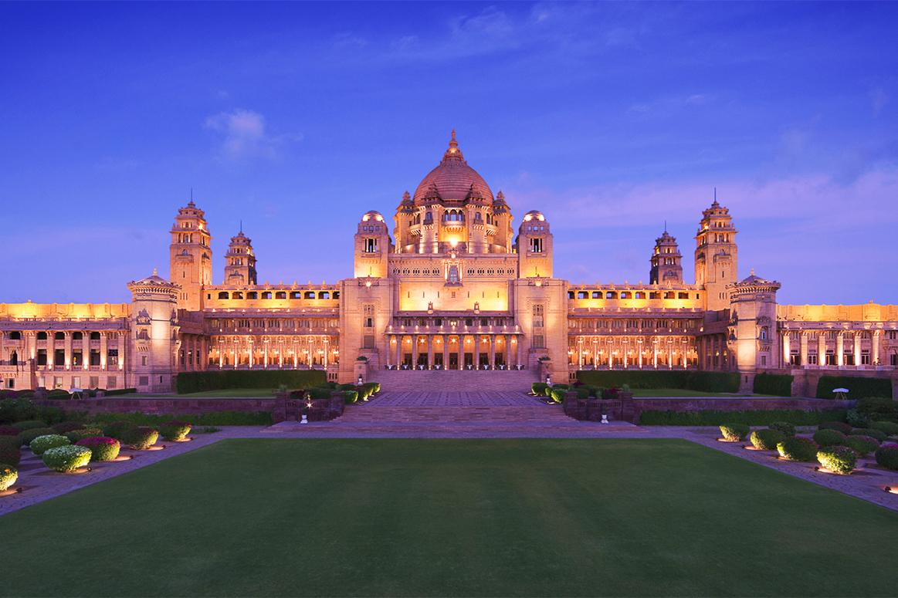

File 2: From our given data, the cheapest hotel was the backpacker panda in Agra with a minimum room rent of Rs 299 per day

(See:  <https://www.backpackerpanda.com/hostels/india/hostels-in-agra/>)

